**NAME: WAJIHA M. ISMAIL**

**STUDENT ID: CSC-18F-073**

**SECTION: 1A**

**SUBJECT: INTRODUCTION TO COMPUTING**

**TEACHER: MS. SAMREEN JAVED**

**TASK # 01 (Flow Chart)**

**COMPUTING:**

The use of computer to process data and perform calculation or act of calculation called computing.

**SOFTWARE:**

Software is the set of instructions that tells the computer what to do.

**HARDWARE:**

Hardware is the physical components of the computer.

**INPUT DEVICES:**

Input devices are those, which is use for feeding data to a computer.

**APPLICATION SOFTWARE:**

Application software is created to perform a specific task.

**SYSTEM SOFTWARE:**

System software have programs which manages the computer itself.

**INPUT / OUTPUT DEVICES:**

I/O devices are those, which perform both input and output functions.

**OUTPUT DEVICES:**

Output devices are those, which gives the result of feeding data.

**EXAMPLE OF SYSTEM SOFTWARE:**

1.Windows

2.Linux

3.Anti-Virus

**EXAMPLE OF OUTPUT DEVICES:**

1.Monitor

2.Printer

3.Speaker

**EXAMPLE OF APPLICATION SOFTWARE:**

1.MS Office

2.Adobe Photoshop

3.Google

**EXAMPLE OF INPUT DEVICES:**

1.Key-board

2.Mouse

3.Scanner

**EXAMPLE OF I/O DEVICES:**

1.Headset

2.Modem

3.Touch-

screen

**TASK # 02**

**MS Word Tool Labeling**

3

1

8

2

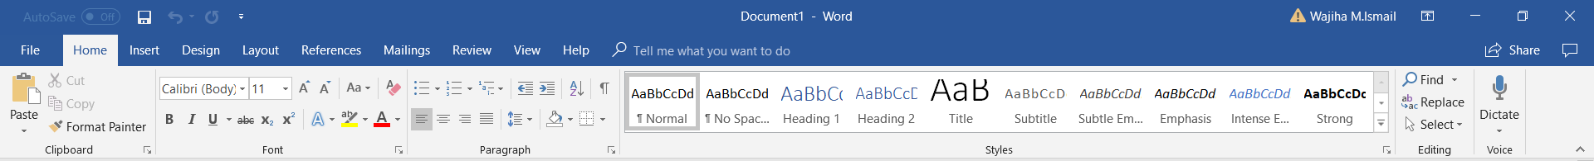

7

4

6

9

5

1. File tab
2. Quick access tool bar
3. Ribbon tab
4. Group
5. Dialogue box launcher
6. Gallery
7. More buttons
8. Window control
9. Collapse